|  |  |
| --- | --- |
| Your GBS Score | Your Certification |
| **Score** | **Merit** |
|  |  |
|  | [DESCRIPTION1]  [DESCRIPTION2] |

Block1

Chart 1

|  |
| --- |
| Chart 1: This chart illustrates your score in each module as well as the average score achieved by your Cohort. Scores are a total of multiple choice and open text questions within GBS. |

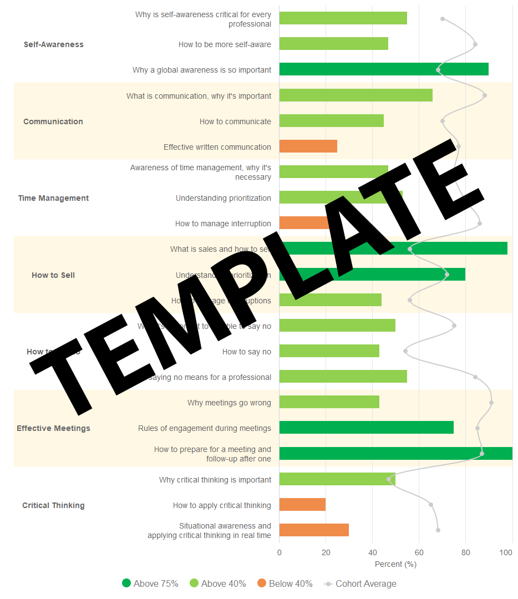

|  |
| --- |
| Chart 2: This chart provides insight into your relative strengths and weaknesses within a topic. Use it to identify concepts that you are strong in and areas you need to work on. |

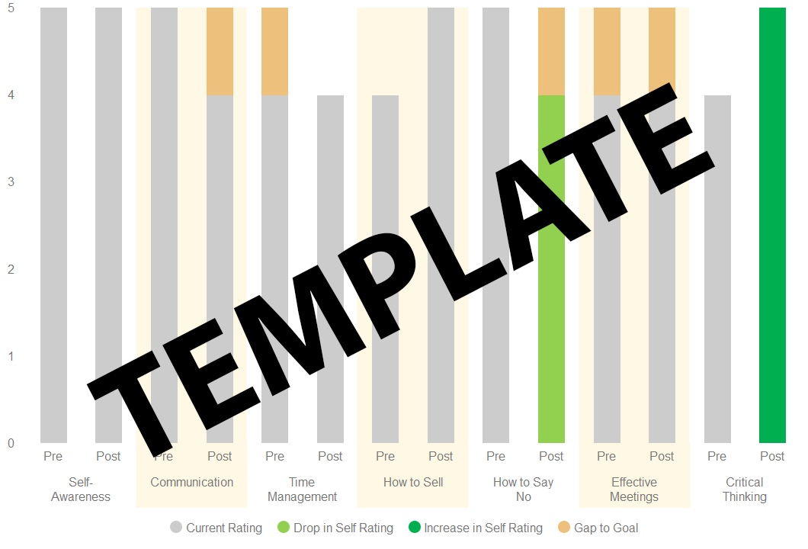

|  |
| --- |
| Chart 3: This chart compiles data from the questionnaires at pre- & post-completion and tracks how your self-rating of current skills and the goal you want to achieve changed as you progressed through the course. It’s designed to help you reflect on current skill levels, goals, and to better understand what gaps need to be covered.   * Rating your current skill levels progressively higher (shown in the darker green where applicable) means you believe you’ve improved. If this is true - aim higher! * If the trend shows you rate your current skill level lower (shown in lighter green where applicable), this can indicate improving self-awareness as you are being more realistic and aspiring in your goals. * Gap-to-goal is the difference between the skill level you’d like to be at and current skill level. You should always be learning and improving your skills and so, having a gap of 0 is undesirable! * Rating your current skill level 5 implies you don’t believe any improvement is needed – or possible! * If you are rating yourself highly, but the scores in the modules show weakness in the same skill – it’s time to seek feedback to see if you have a blind spot that needs addressing. |

Block 2

|  |  |  |  |  |  |  |  |  |  |  |  |  |
| --- | --- | --- | --- | --- | --- | --- | --- | --- | --- | --- | --- | --- |
| **Certification Levels**   |  |  |  |  | | --- | --- | --- | --- | | **None** | **Completion** | **Merit** | **Distinction** | |  |  |  |  | | 1 or more modules < 40% | All modules >= 40% | All modules >= 40%  At least 5 >= 75% | All modules >= 75% |   **Cohort Performance**  Charts 1 and 2 provide comparative data on how the rest of your Cohort performed – use it as a guide to understand where you where you stand relative to others in your cohort.  This learning program is about individual and team-based skill upgrades and so, it is important to understand how your team/cohort is progressing toward being a collective, high-performance organization. |